# TITLE OF THE PAPER, CAMBRIA, 14 FONT SIZE, CENTER, BOLD, ALL UPPERCASE LETTERS 50 TO 100 CHARACTERS

Author Name1, Author Name2 and Author Name3 (Full Names, No Abbreviation)

1Faculty, University, Country; 2,3 Company, Country

## Abstract

Please read all the information given in this Template carefully before starting to type. The paper must contain at least 8 Figures and/or Tables. Please use Cambria 10 Font size. The paper title must be between 50 to 100 characters in length. The abstract must contain a "Problem statement, Approach, Results, and Conclusions." The size of the abstract must be between 200 ~ 250 words. Please use this document as a template. The paper length should be 4 to 6 pages long. Any page or fraction thereof exceeding 6 pages will be charged extra fees. The additional author fee is needed if exceeding 5 authors. If the paper is NOT according to this Template – it will NOT be published in the proceedings. The author must pay to register for the inclusion of the conference paper in the proceedings. Please double-check that there are ten font sizes throughout the paper except for the title, which is 14 font sizes only. Do not write the author's email or position in the author's section above. Only use the name of the Department or Faculty, University, and Country.

*Keywords: Three or five keywords (The first characters of each keyword are in uppercase letters), Italic*

## HEADINGS

Use at most three levels of headings that correspond to chapters, sections, and subsections. The first level headings for chapter titles should be in 10pt, bold, justified, and upper case font. Leave one blank line before and after the first level headings, respectively.

**The Second Level Headings**

The second-level headings should be in 10pt, bold, justified, and the First Characters of Each Word are in Capital font. Leave one blank line both before and after the heading, respectively

The third level headings

These headings should be in 10 pt, italics, and sentence case. Insert one blank line before the headers but no line space after the headers. Further lower-level titles should be avoided. Follow the style exactly of this Template.

## tables AND figures

Figures or Tables should be sized the whole width of a column, as shown in Table 1 or Fig.1 in the present example, or the entire width over two columns. Do not place any text besides the figures or tables. Please do not put them together at the end of the manuscript.

Table 1 This is an example of table formatting

|  |  |  |  |
| --- | --- | --- | --- |
| Items | x | y | z |
| a | 5 | 2 | 5 |
| b | 6 | 1 | 6 |
| c | 8 | 3 | 9 |
| d | 10 | 4 | 11 |

*Note: Should be placed under the table, leaving no space in-between; 8-10pt font, and left- and right-justified.*

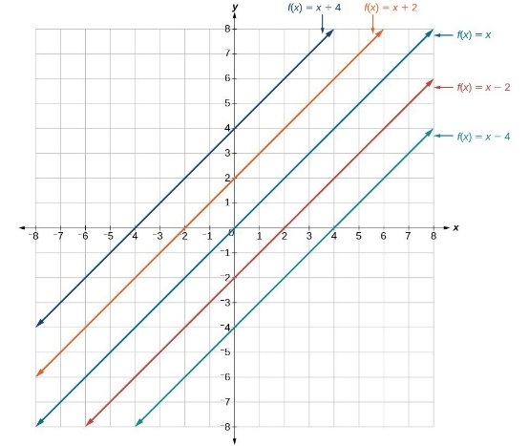

Fig.1 This is a good example of figure formatting

**STYLE**

Use in-text citations. Follow the APA style manual guidelines for in-text citations and bibliographic information. See <https://apastyle.apa.org/style-grammar-guidelines/references> for more information about the reference list. If the title of a work uses a non-Roman alphabet (e.g., Korean, Chinese, Japanese, Hindi, Thai, Hebrew, Arabic, etc.), transliterate the title and then provide the translation in brackets. For more information and examples, see <https://apastyle.apa.org/blog/transliterated-titles-references>. Use American spelling.